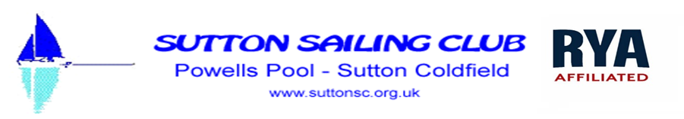

Sutton Sailing Club
Reviewed 24/10/25
Social Media Policy
This policy provides guidance on how Sutton Sailing Club (SSC) members use our WhatsApp and Facebook social media groups. It also outlines how we expect adult and child members of SSC to behave online.
Aims
The aims of our online safety policy are:
• To protect all children involved with SSC who make use of technology (such as mobiles phones and the internet).
• Provide our members with policy and procedure information regarding online safety and inform them how to respond to incidents.
• Ensure that SSC is operating in line with our values and within the law regarding how we behave online.
What we expect of our members
- All members – adult & child - should be aware of this policy and behave in accordance with it.
- Members should seek the advice of the Club Welfare Officer if they have any concerns about the use of the club social media groups.
- Emails or messages should be written in a respectful manner in the same way you would communicate with fellow professionals. No one should use slang, inappropriate language or inappropriate emojis.
Guidance for use of Club WhatsApp Group and Facebook Group
• Behaviour in the group reflects the Club’s reputation and it is everyone’s responsibility to uphold this.
• The content of everything posted in the Group must be appropriate for all who may read or access it and must not be upsetting or offensive to anyone.
• The content should be limited to sailing and club business – e.g. saying if you will be at the club on a certain day, information about the weather, sailing events.
• For children (those under 18 years of age) to be members of the Group their parent/guardian must give written consent to the Club Welfare Officer.
• No adult member should communicate online outside the Group with any child member.
• Any photographs posted in the Group should be general – e.g., showing activities on the water- and should not feature any children in such a way that they can be identified unless the photographs are posted by the child’s parent or other person who holds Parental Responsibility for the child.

