FULL NAME
DATE OF BIRTH
ADDRESS

POSTCODE
TELEPHONE
MOBILE
EMAIL ADDRESS
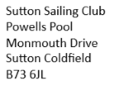
Membership Application Form

NAME OF SPOUSE/PARTNER | DATE OF BIRTH
CHILDRENS’ FULL NAMES | DATES OF BIRTH

Boat Class | Sail Number | Boat Name

Type of Membership required | Please Tick
See fees on additional sheet attached.
Family membership (includers spouse and children over 18 on
1st April)
Single Full
SUP Family
SUP Single
Student
(in full time education on
1st April)
Junior
Under 18 on 1st April
Sea Scout
Social Member
Model Boat
Honorary Life Member
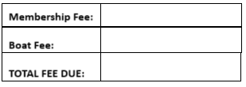
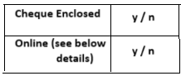

Online payment can be made to Sutton Sailing Club, HSBC Bank,
Sort code 40-43-28, Account number 60785903.

Applicants are urged to read the RYA leaflet ‘Blue Green Algae the facts’, a copy of which is displayed on the club notice board. Alternatively please view the Blue Green Algae notice on our website at www.suttonsc.org.uk/ - see the Sailing Courses tab.
Acceptance of membership by Sutton Sailing Club does not hold them liable in the event of personal injury, loss, damage or death either for damages or costs.

Junior applicants should obtain their parent/guardian’s signature to the following statement:

I approve of my Son / Daughter becoming a member of Sutton Sailing Club and I am confident of his / her swimming ability for sailing.

I hereby apply for membership of Sutton Sailing Club, which shall be considered in accordance with the club rules, and I agree to abide by the club rules during my membership.
I confirm that any boat I launch onto Powells Pool will be covered by at least £2,000,000 Third Party Indemnity Insurance (this includes my taking out separate personal insurance if needed, in accordance with club rules).

Applicant’s Signature ………………………………………………………………………………Date…………………………………
(Parent/Guardian signature if applicant is under 18yrs)

